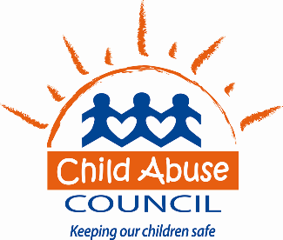

Dear Family:

Your child’s class will begin using Second Step: Child Protection Unit Curriculum during this school year. This program teaches children skills that will help them keep safe from dangerous or abusive situations. Children will learn pedestrian, car, and fire safety, along with how to ask for help when they need it.

This curriculum is part of your child’s preschool program. It is supported through a partnership with the Child Abuse Council and your child’s early learning center.

Over the course of the program you will receive a series of Home Links and Family Letters that provide information about how you can help your child learn and practice safety rules taught in the classroom lessons. Children learn more about safety and are more likely to follow safety rules when they have multiple opportunities to practice and talk about safety with their family. I’d like to encourage you to help your child learn and practice safety rules.

The lessons in the program start with basic safety rules such as properly crossing a street and wearing seat belts. We then move on to more serious topics such as fire safety, asking first before accepting gifts or leaving with people and keeping our bodies and private body parts safe. The curriculum was developed specifically for prekindergarten children.

I will be working with your child’s teachers and providing support to them through the program. If you have any questions or concerns, please feel free to contact me.

Sincerely,
Heather Lamb
Prevention Education Specialist
Child Abuse Council
HeatherL@childabuseqc.org
309-736-7170 x113

☐ YES! My child has permission to participate in Second Step: Child Protection Unit Curriculum.

☐ No, I do not wish to have my child participate in this safety curriculum.

Child’s Name: ______________________________________

Signature: ______________________________________________ Date: ________________

